**Chaldal.com**

**Issue1:** After changing the website language from English to Bangla, some of the features names still remain in English.

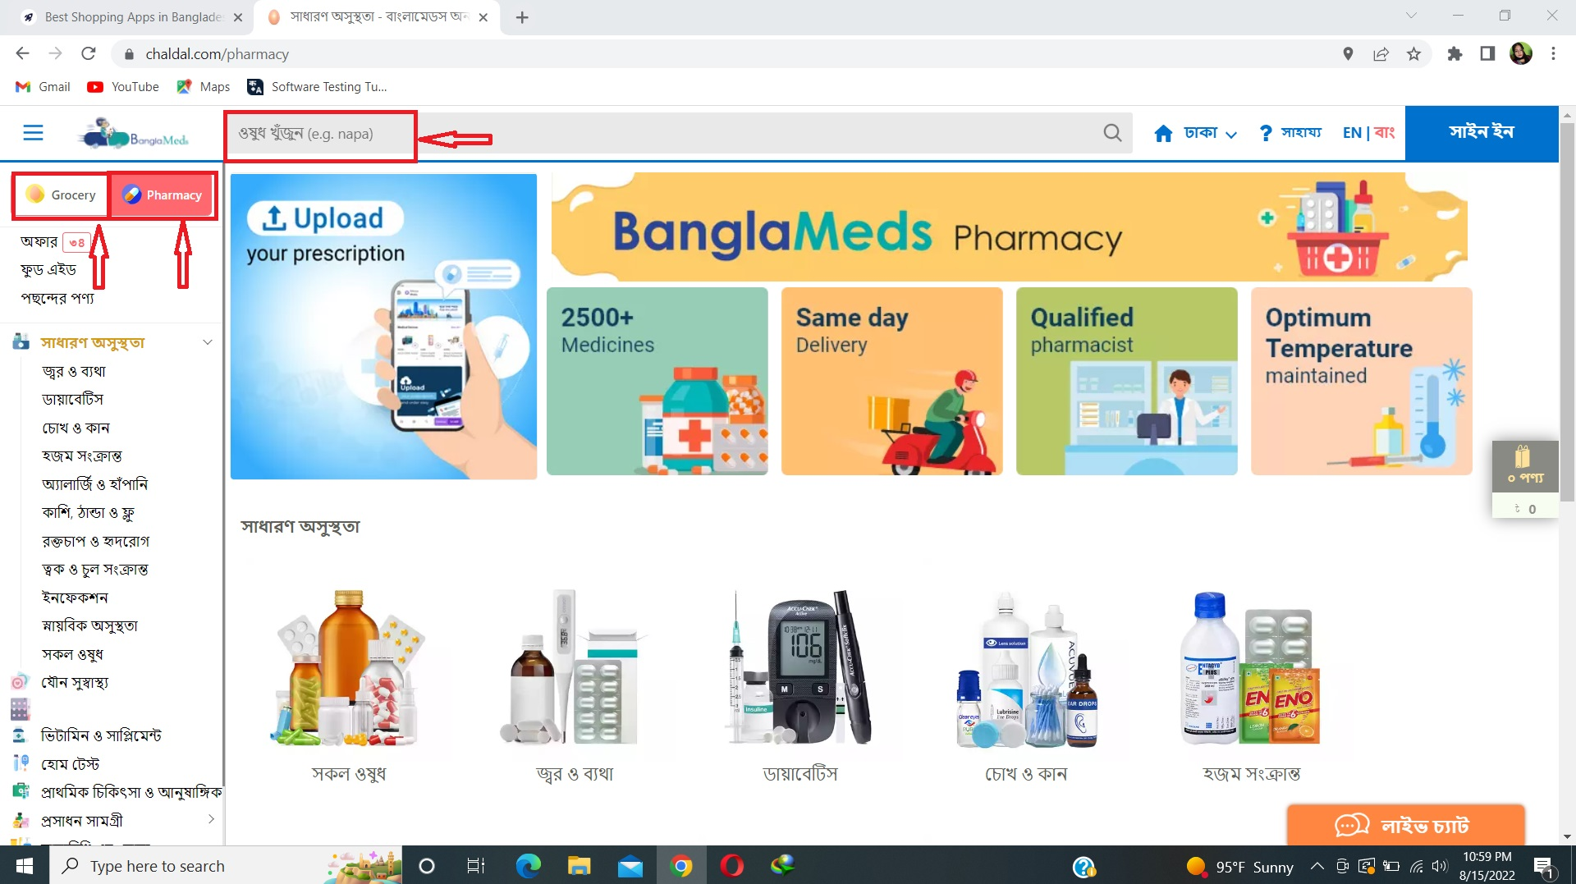

1. Go to URL (<https://chaldal.com/> )
2. Click on বাং to change the language from English to Bangla.
3. “Grocery” and “Pharmacy” names are still shown in English.
4. Click on “Pharmacy”
5. In the search button option half sentence is in Bangla and half sentence is in English.

**Observation,** Grocery and Pharmacy name should be in Bangla and in search button option full sentence should be in English.

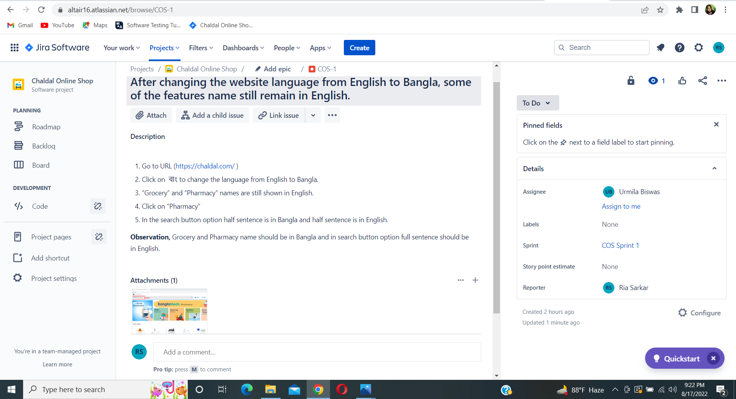

**Description:** The work was assigned to Urmila Biswas for solving the issue.

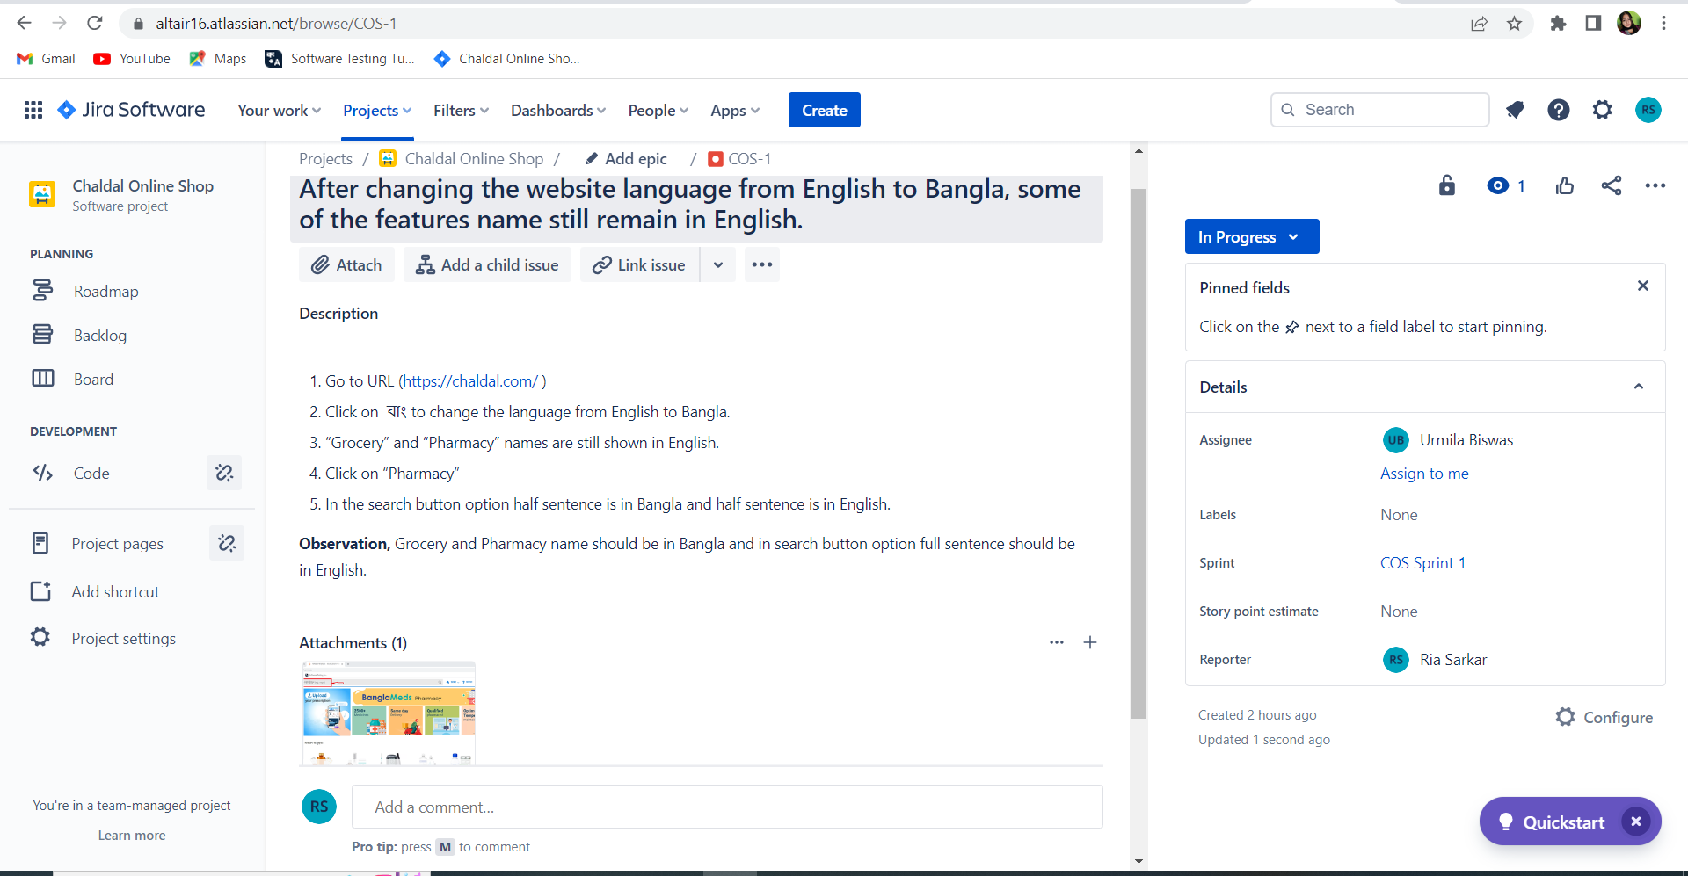

**Description:** The developer was working on it and it was in the progress stage.

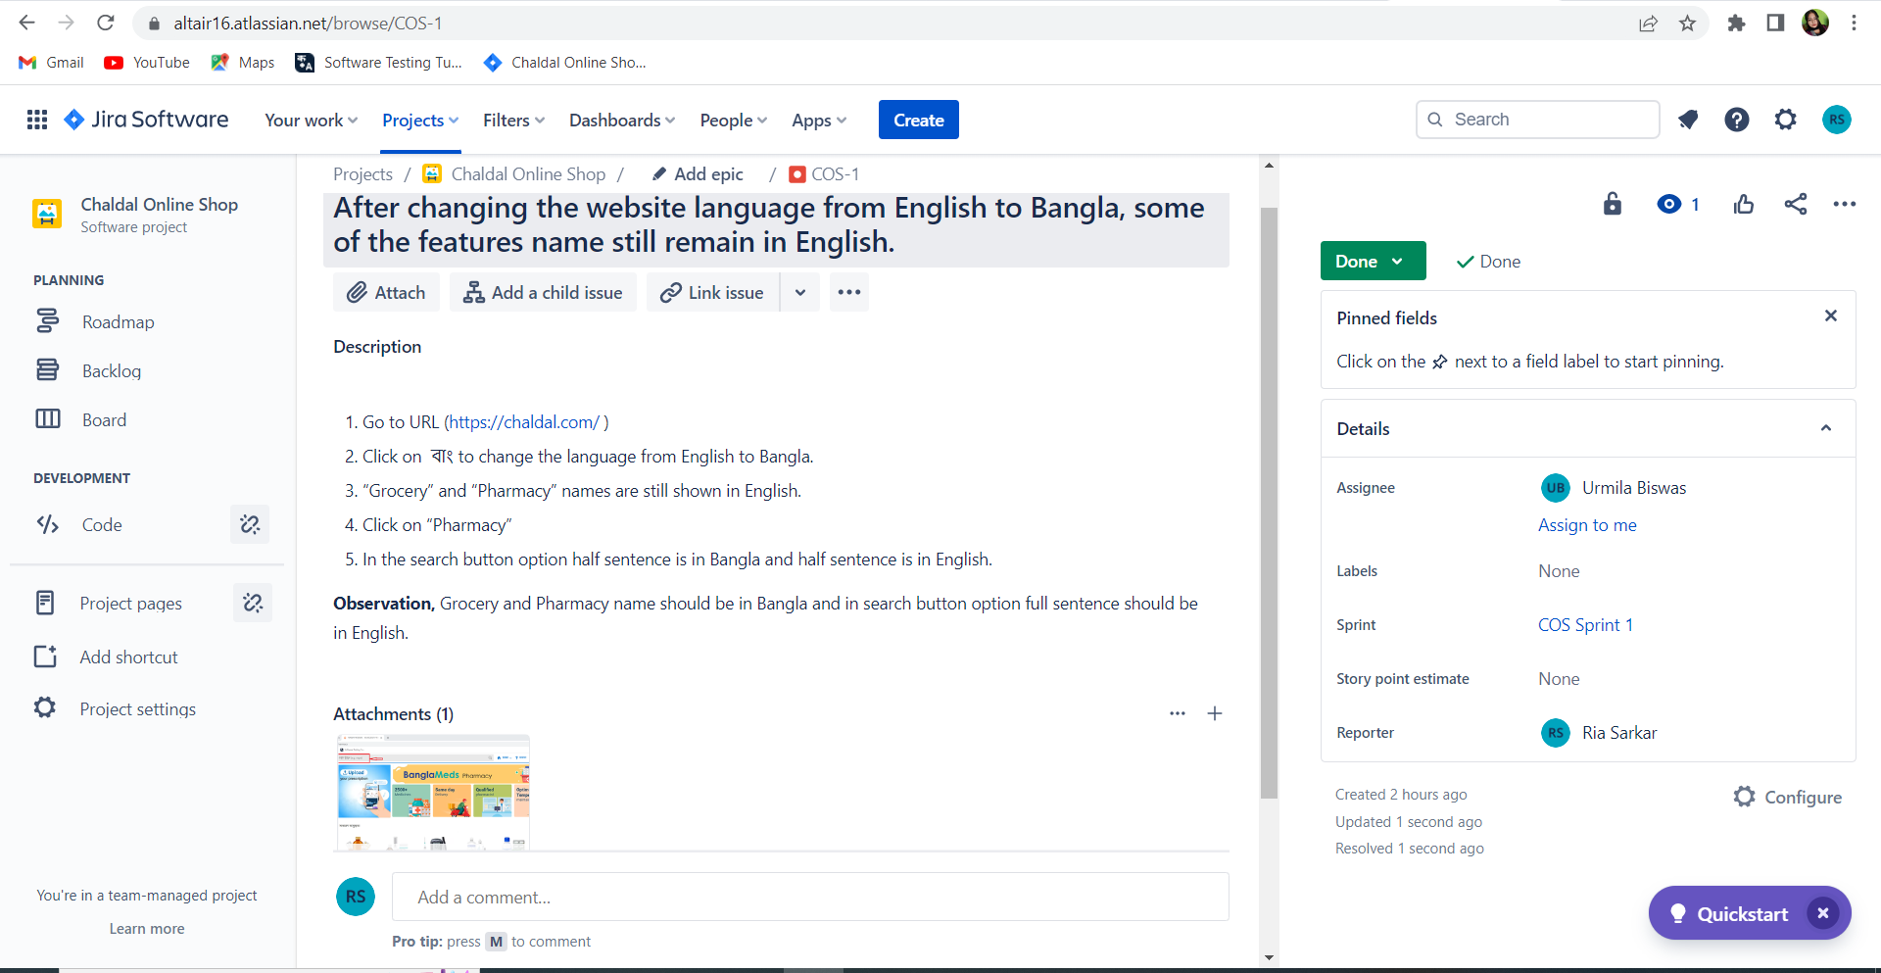

**Description**: Developer completed the work and the work is done.

**Issue2:**After changing the website language from English to Bangla, some of the features' names still didn't change.

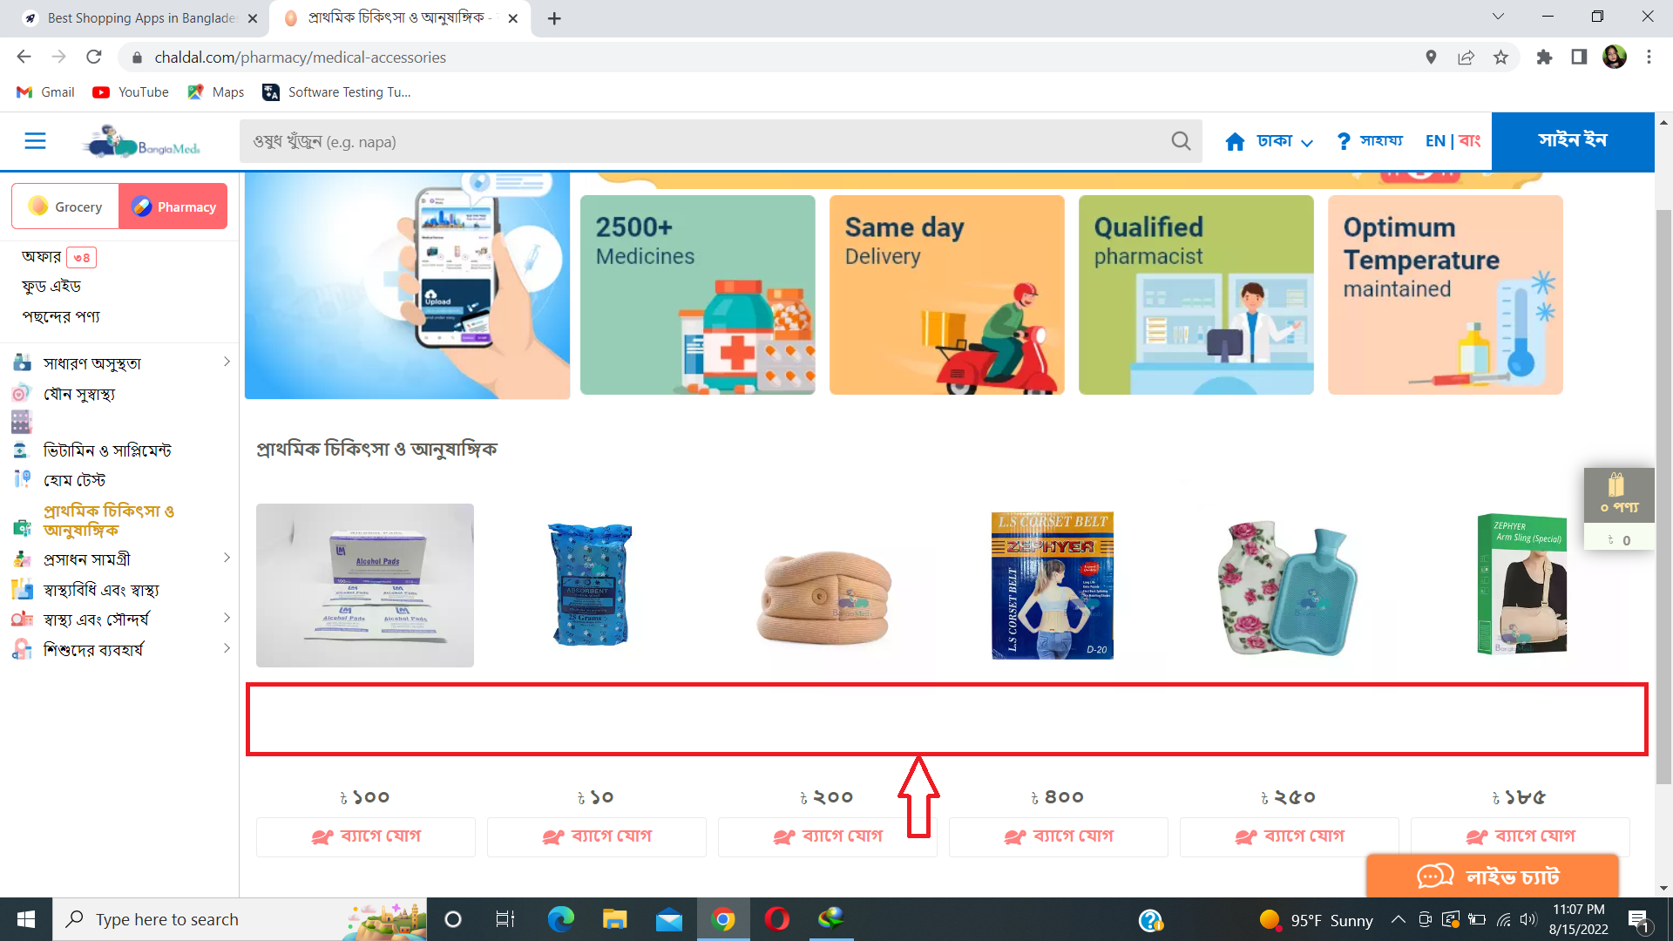

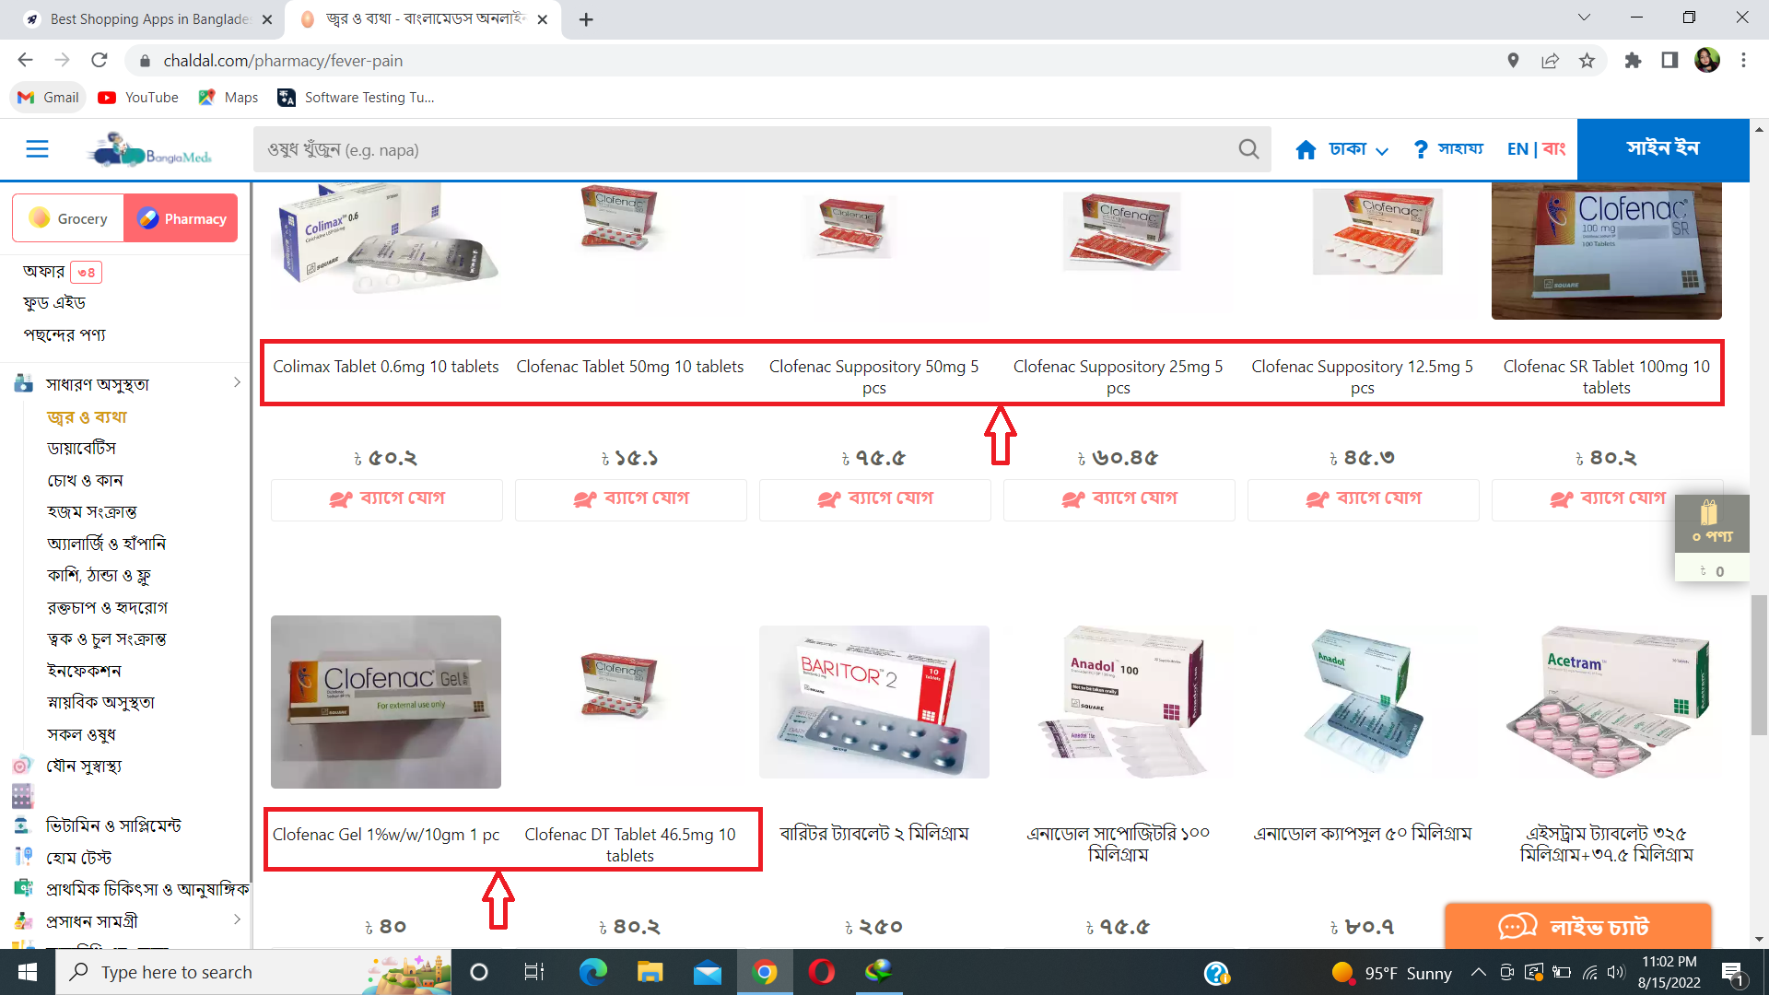

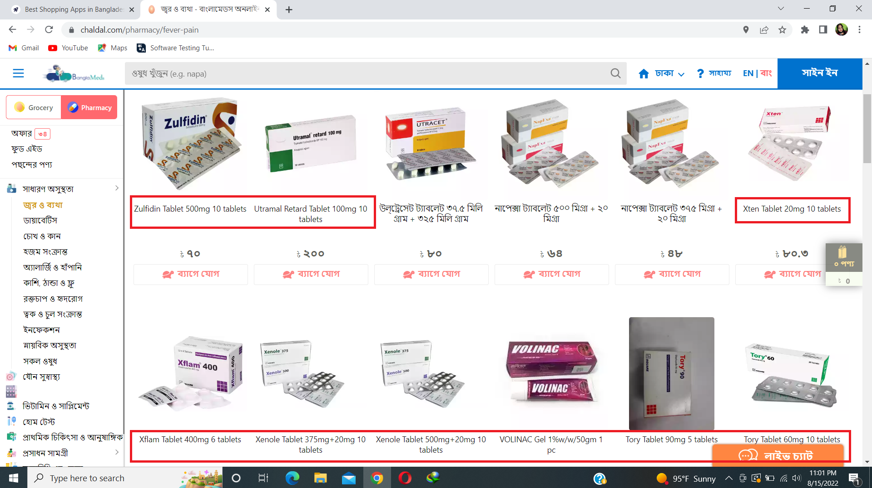

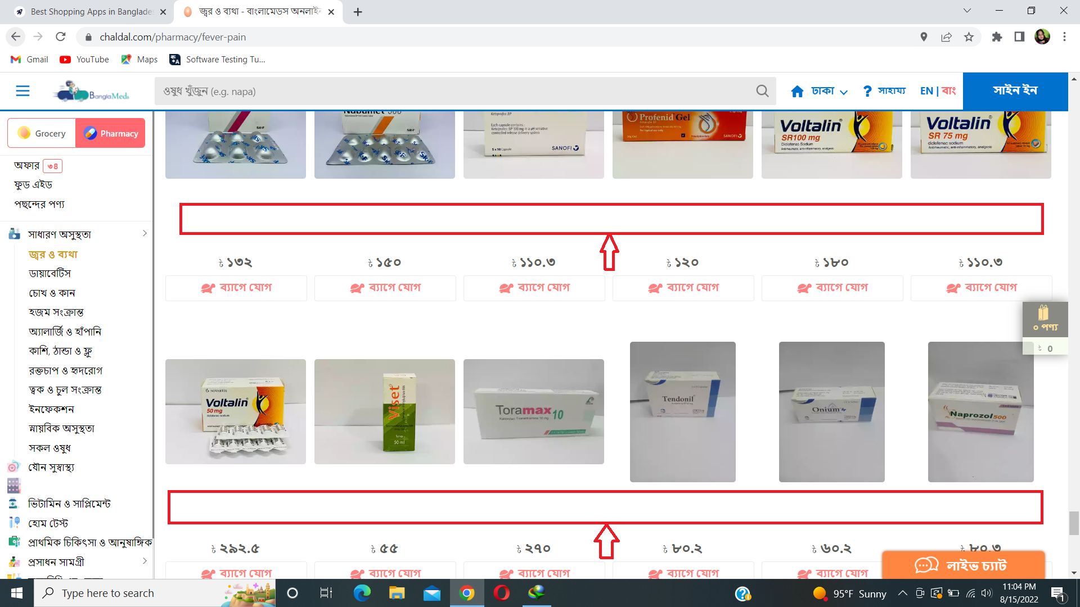

1. Go to URL (<https://chaldal.com/> )
2. Click on বাং to change the language from English to Bangla.
3. Click on “Pharmacy”
4. Some medicines' names didn’t turn into Bangla and some of the medicines' descriptions remained empty.

**Observation,** Medicines should be in Bangla and also should have some descriptions.

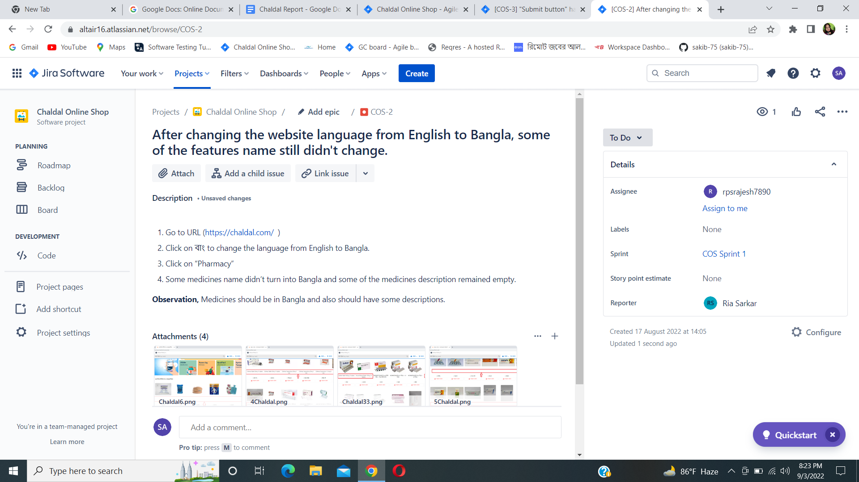

**Description:** The work was assigned to Rajesh Sarkar for solving the issue.

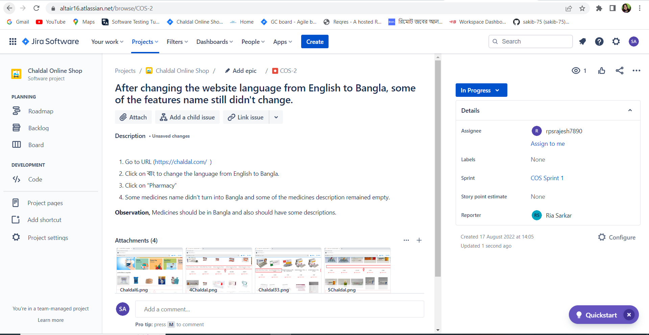

**Description:** The developer was working on it and it was in the progress stage.

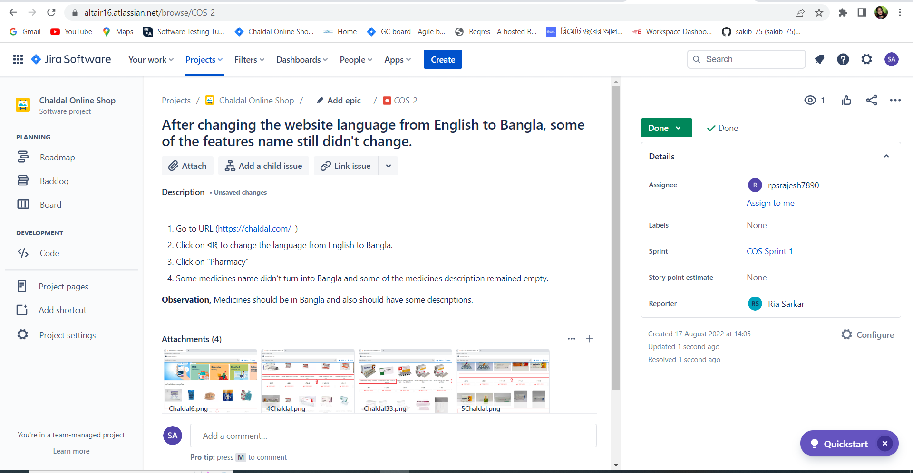

**Description**: Developer completed the work and the work is done.

**Issue3:**"Submit button" half portion goes into the footer section, when trying to create an account in Chaldal Food Aid.

1. Go to URL (<https://chaldal.com/> )
2. Click on Food Aid
3. Click on the “Food Aid Request” button.
4. Enter phone number and click on Submit button.
5. Enter OTP and enter submit.
6. Enter Name and date of birth and click on Submit.
7. Submit button’s half portion went on the footer section and that portion didn’t work.

**Observation,** Submit button should not go to the footer section and the full portion should be work.

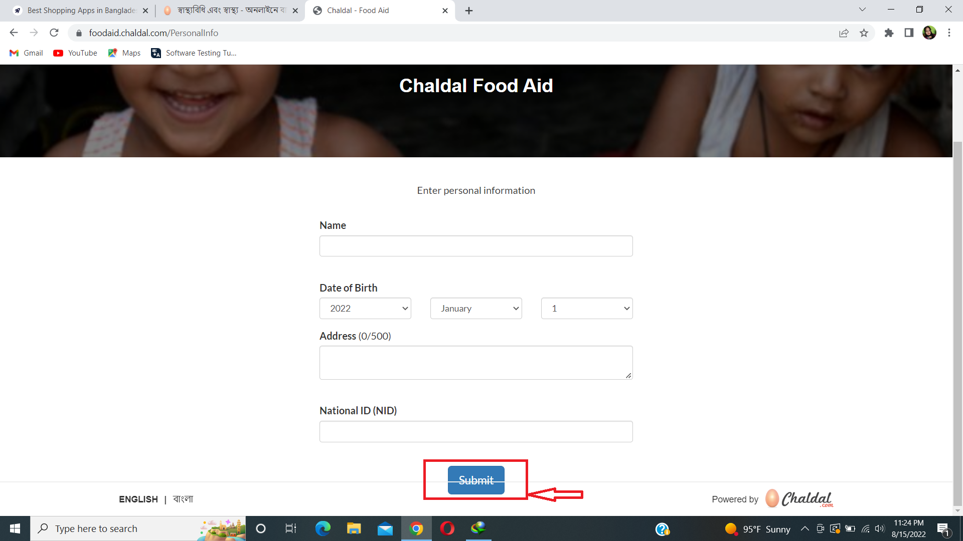

**Description,**

1. Click on Food AidClick on Food Aid
2. Click on the “Food Aid Request” button.
3. Enter phone number and click on Submit button.
4. Enter OTP and enter submit.
5. Enter Name and date of birth and click on Submit.
6. Submit button’s half portion went on the footer section and that portion didn’t work.

**Observation,** Submit button should not go to the footer section and the full portion should be work.

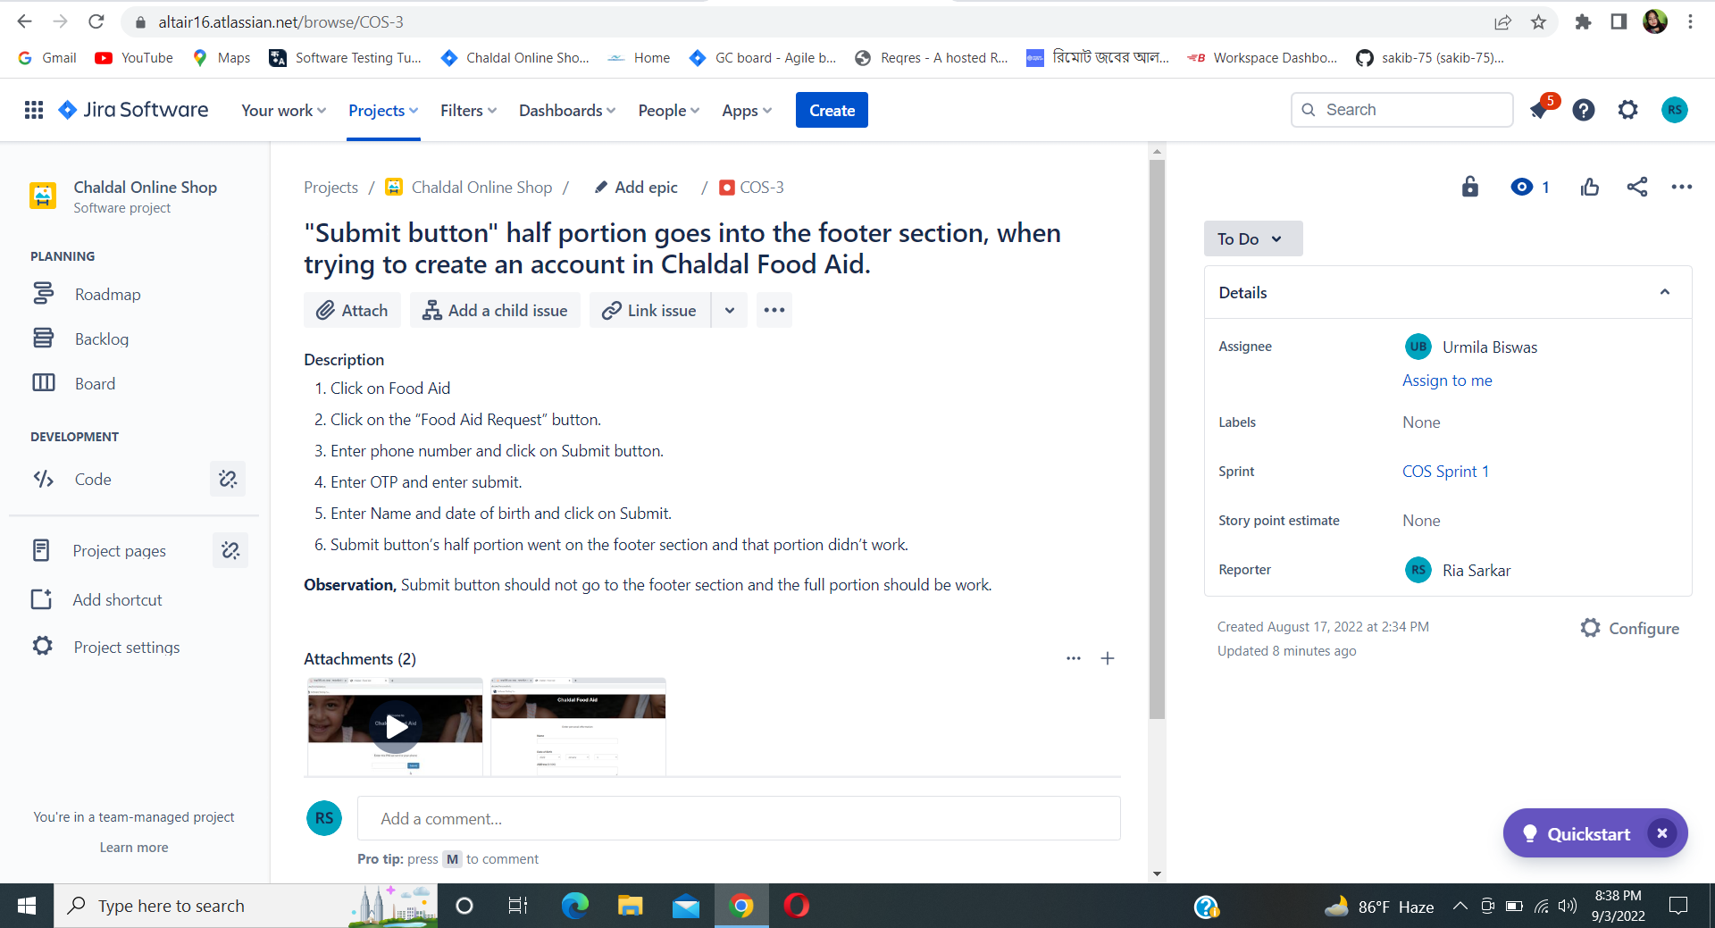

**Description:** The work was assigned to Urmila Biswas for solving the issue.

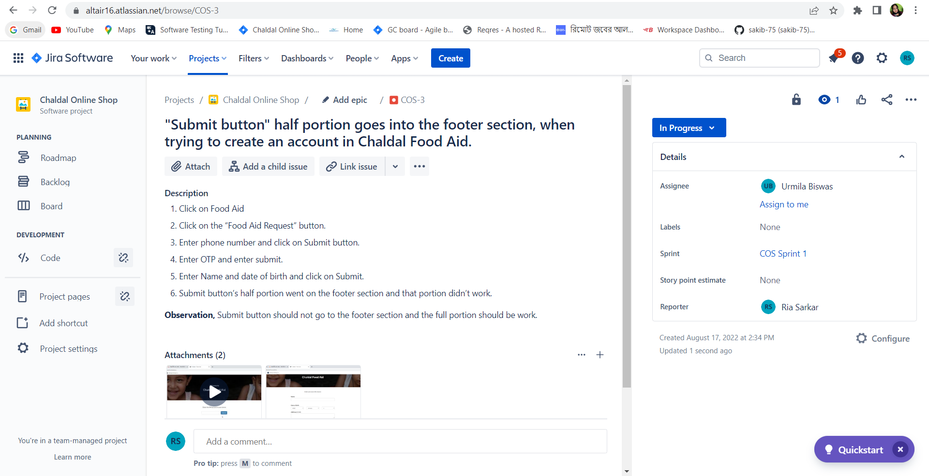

**Description:** The developer was working on it and it was in the progress stage.

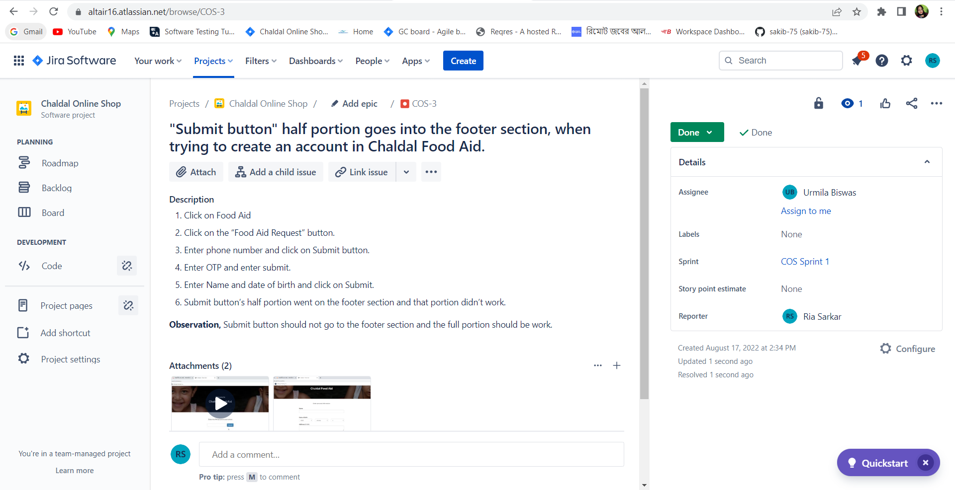

**Description**: Developer completed the work and the work is done.

**Issue4:**When I try to load my current location, it does not work and some features keep loading.

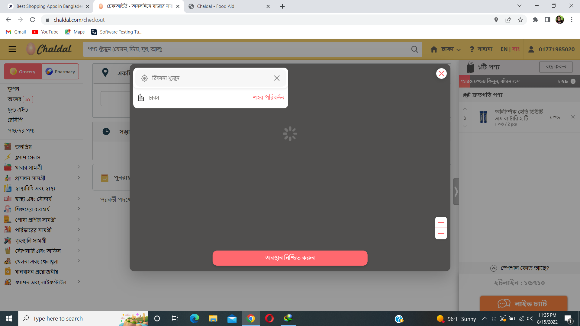

**Description:**

1. Go to URL (<https://chaldal.com/> )
2. Click on Dhaka to select the location.
3. Click on “Use my current location.”
4. It does not work and also shows nothing.
5. When we want to buy something and go for checkout, then if we select “Use my current location” option, it keeps loading and loading.

**Observation**, “Use my current location” option didn’t work in any situation. This option should be fixed.

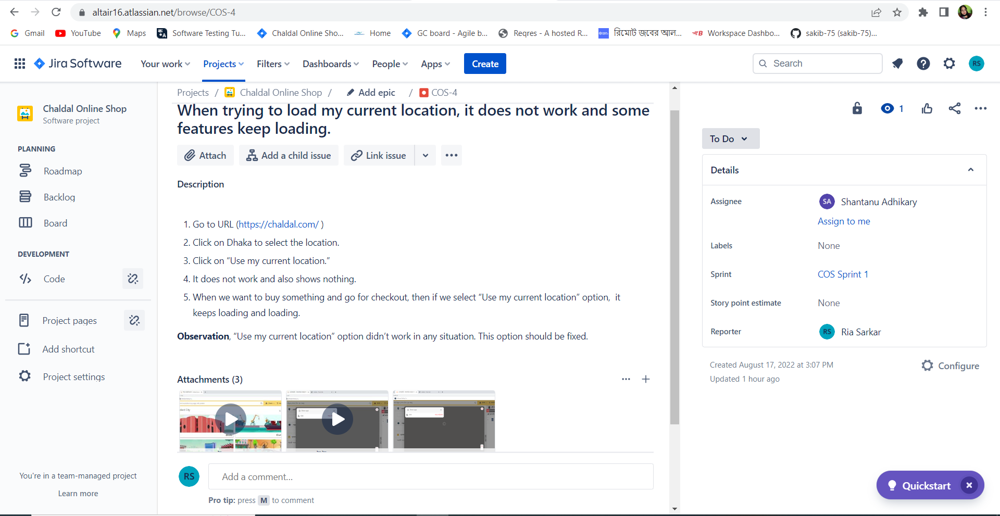

**Description:** The work was assigned to Shantanu Adhikary for solving the issue.

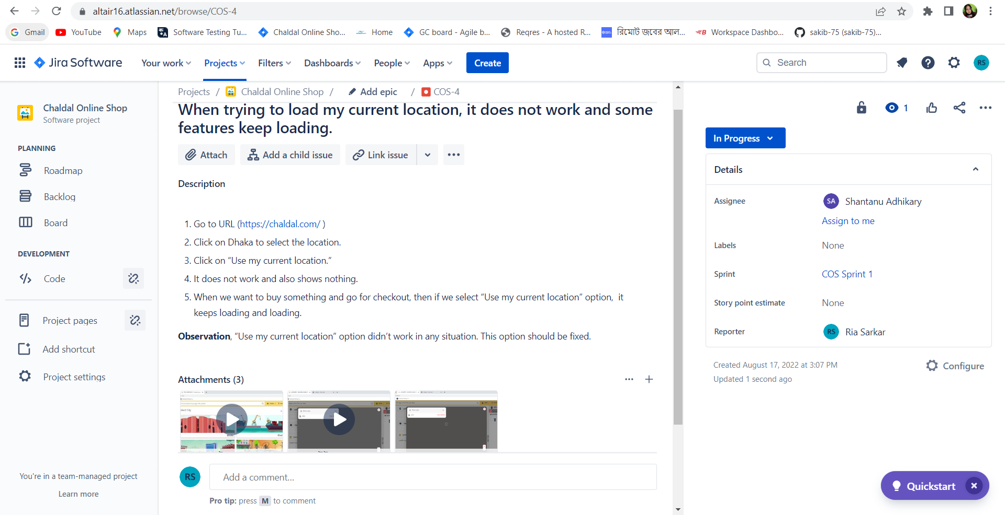

**Description:** The developer was working on it and it was in the progress stage.

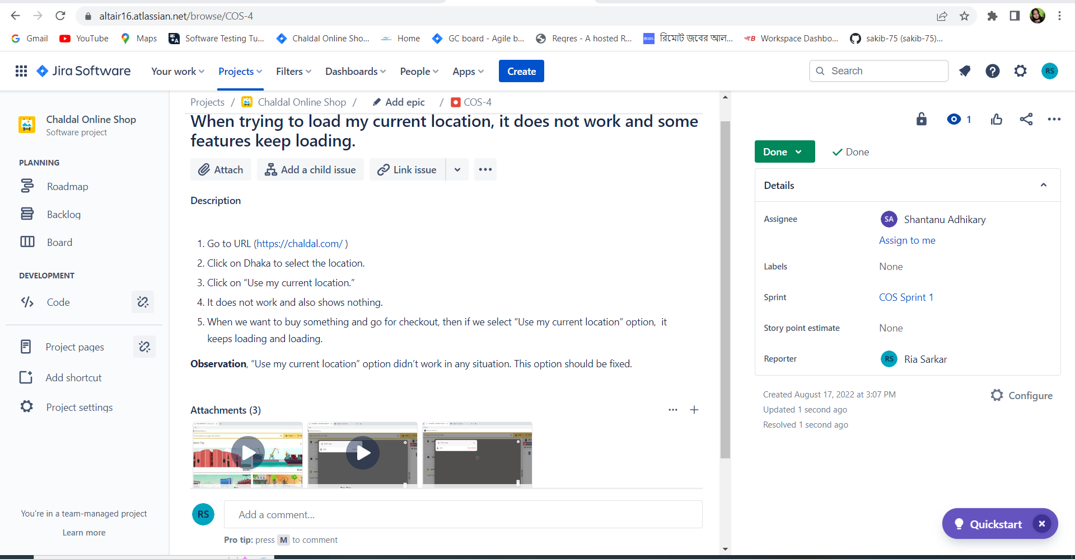

**Description**: Developer completed the work and the work is done.

**Issue5:** Account phone number didn't change into Bangla.

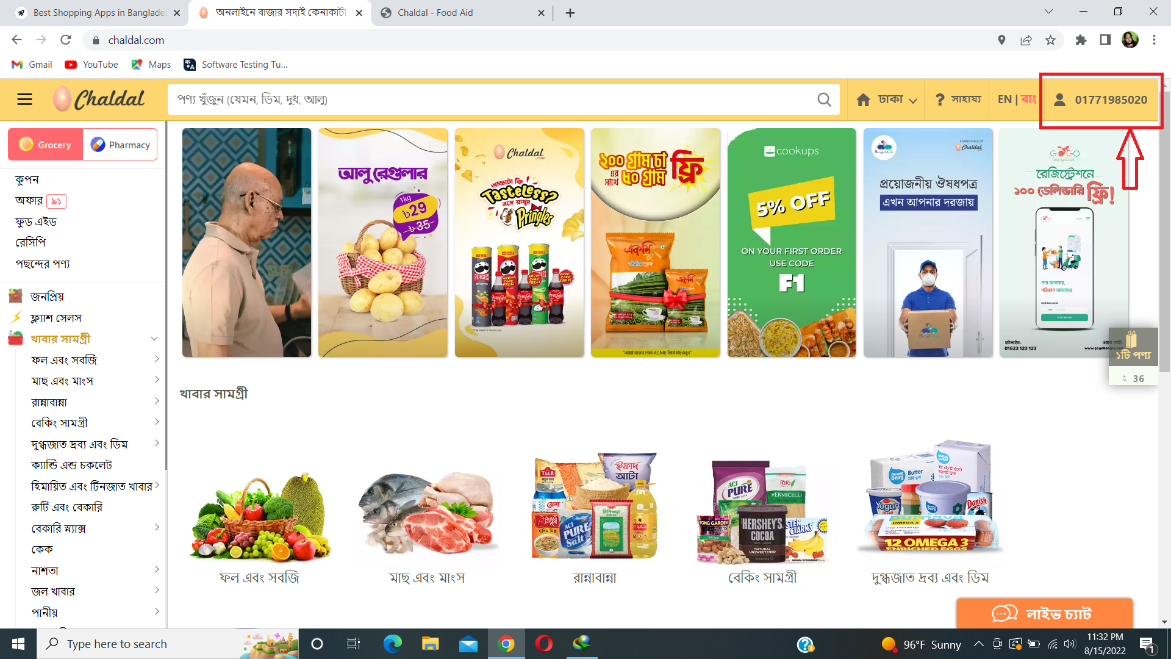

**Description:**

1. Go to URL (<https://chaldal.com/> )
2. Click on “Sign in “
3. Enter a phone number and click on the Sign up/Login button.
4. Change language from English to Bangla.
5. Phone number didn’t change.
6. Page margin also should be changed.

**Observation**, Phone number didn’t change into Bangla and page margin isn’t correct. It should be changed.

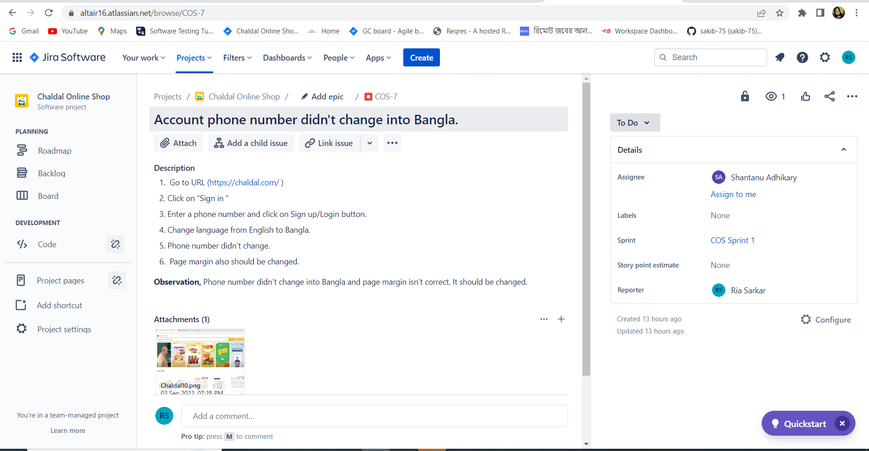

**Description:** The work was assigned to Shantanu Adhikary for solving the issue.

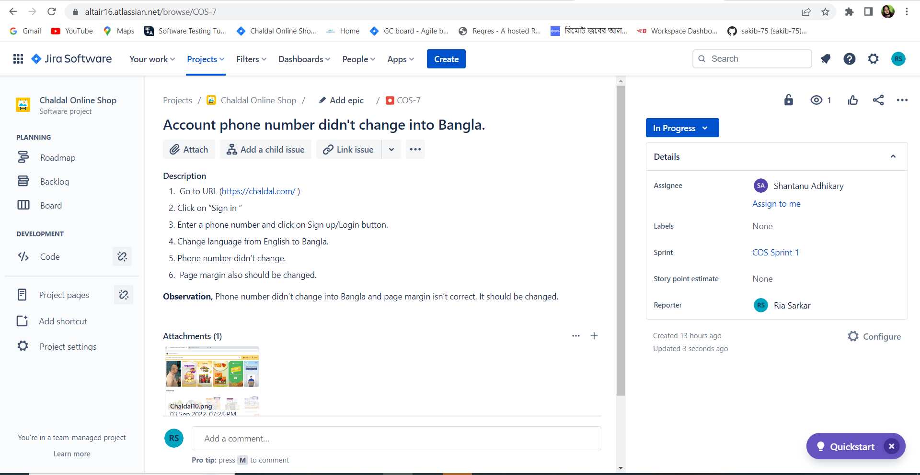

**Description:** The developer was working on it and it was in the progress stage.

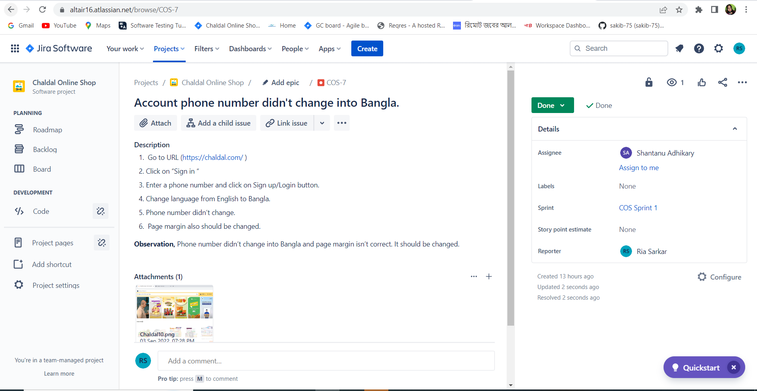

**Description**: Developer completed the work and the work is done.

**Issue6:** Page margin is not correct and recipes information keeps loading.

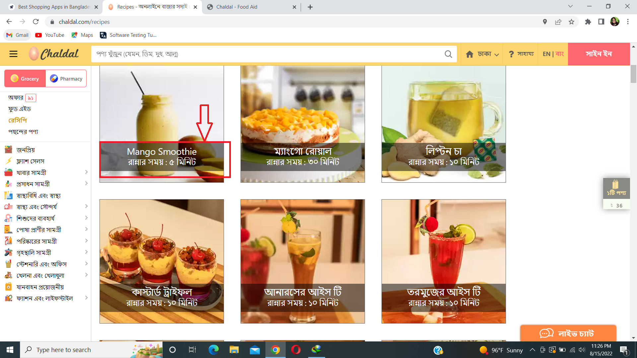

**Description:**

1. Go to URL (<https://chaldal.com/> )
2. Click on “recipes “
3. All the recipes go to the left side in the page of Chaldal website .
4. Also when changing the language, it takes too much time to change the language and it keeps loading.

**Observations**, Page margin should be changed and recipes loading should be fixed.

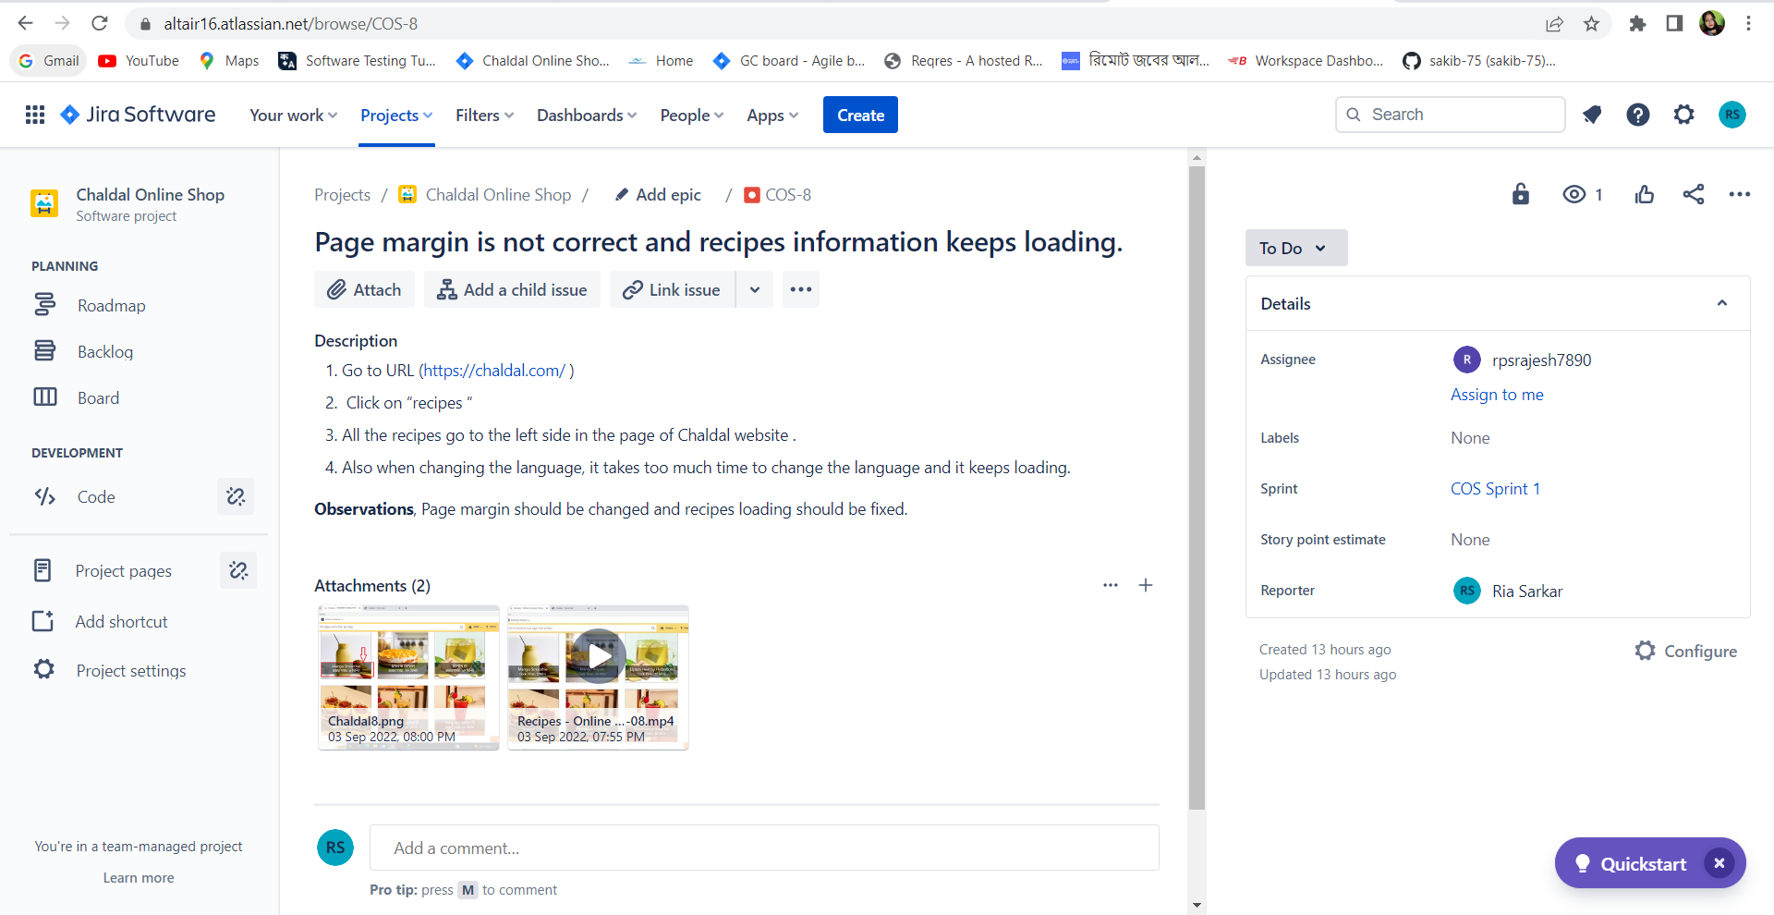

**Description:** The work was assigned to Rajesh Sarkar for solving the issue.

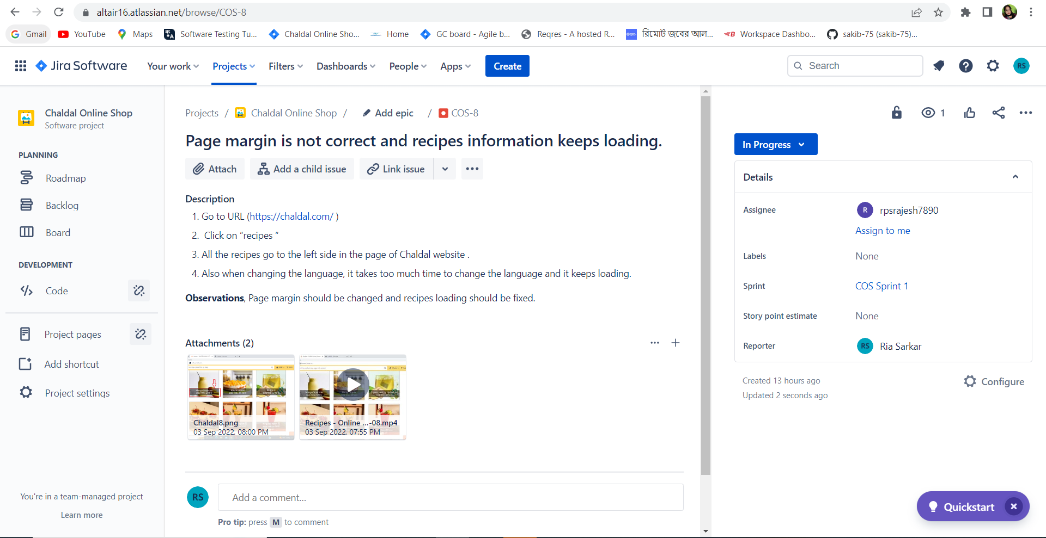

**Description:** The developer was working on it and it was in the progress stage.

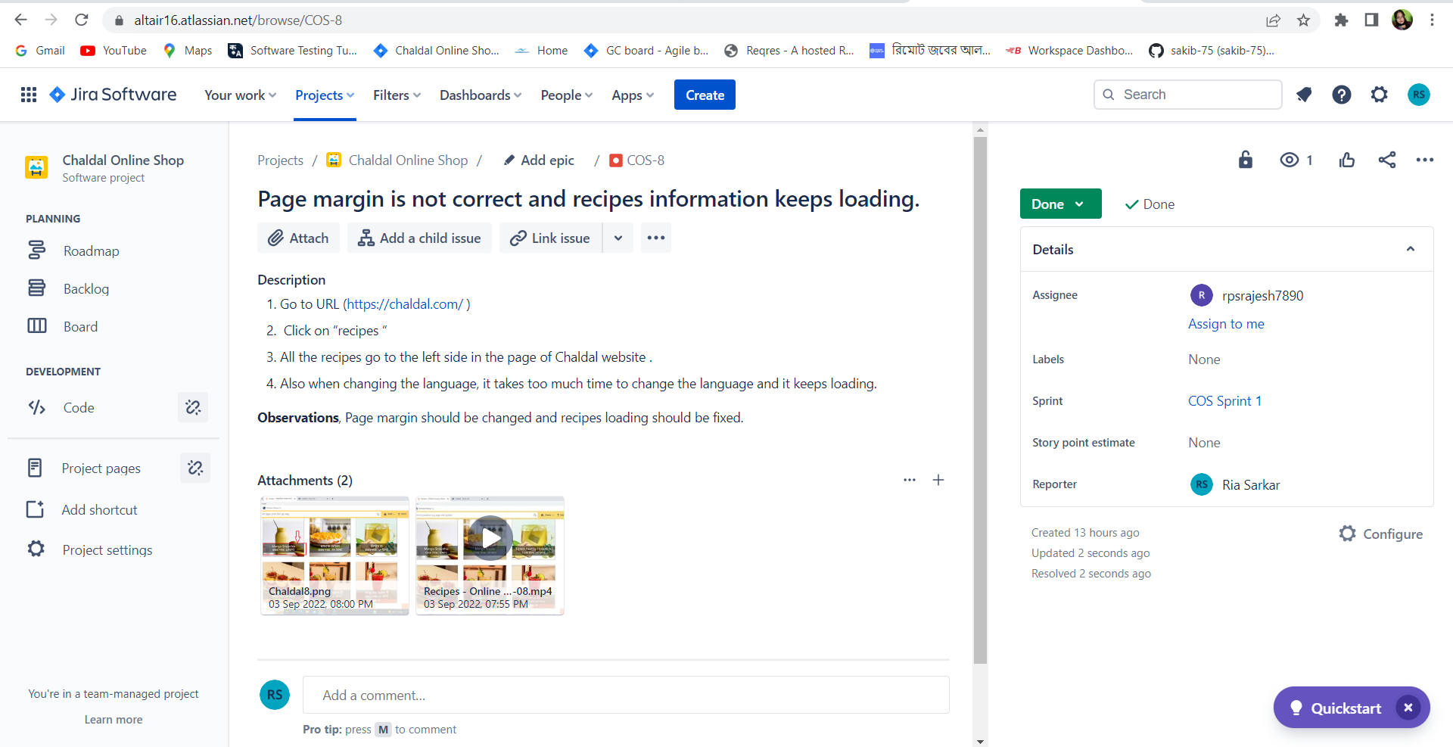

**Description**: Developer completed the work and the work is done.